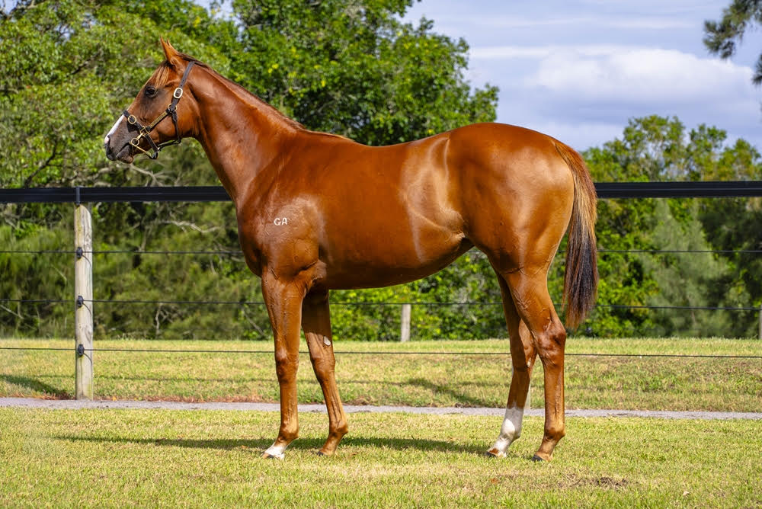
EXTREME WARRIOR is a very exciting young stallion currently sitting 8th on the first season sires table. He has had 6 runners for 2 winners one of them at stakes grade.
He is a son of the freakish stallion EXTREME CHOICE and he himself was a good 2yo placing twice at stakes grade then improving into his 3yo year winning the G3 Blue Sapphire and Listed Bel esprit stakes.
On the back of his current success as a stallion his sales record is starting to trend in the same direction. He has sold 9 horses this year for an average of $127,222. Including topping the book 2 sale of the Melbourne premier sale with a colt that made $220,000.
MARQUIS DELAGUICHE is a very well-bred mare. Stemming from the same family as the best 3yo filly in Australia TEMPTED. There is no less than 18 Black type performers within her first 2 dams!
Including and not limited to - Lizard Island, Marsannay, Cardigan Queen, Athletica, BULLA BORGHESE, BOUND FOR EARTH, Melpomene, CALLIOPE, KALLOS, TEMPTED, ZETHUS & BACCHANALIA.
Significant pedigree updates since the catalogue went to print are those of –
TEMPTED (2022.f. by Street Boss-Calliope, by Exceed and Excel-Melpomene).
1st ATC (Randwick) Surround S. Gr.1
1st ATC (Randwick) Eskimo Prince S. Gr.3
Zambales (2023.c. by Pinatubo-Calliope, by Exceed and Excel-Melpomene).
2nd VRC (Flemington) Sires' Produce S. Gr.2
2nd VRC (Flemington) Talindert S. L
4th MRC (Caulfield) Blue Diamond S. Gr.1

A 24th August foal and a family full of 2yo speed I expect this filly to be up and going early. She will be targeted at the Magic Millions race day in January. Two races in particular look very attractive to us.

Both on the 17th of January –
- The Star Gold Coast Magic Millions The Debut for unraced 2YOs C,G&F – SW with prizemoney of $500,000 + $2,000 trophies over 1000m
- TAB Magic Millions 2YO Classic Restricted Listed – SW worth $3,000,000 + $5,000 trophies AND $500,000 Racing Women's Bonus + $3,500 trophy over 1200m.

SHARES ARE AVAILABLE FROM 2.5% AND UPWARDS
Total cost is $24640
2.5%-$616
5%-$1232
10%-$2464

